**PROCEDURE :-**

Step 1 : Go to [www.Nagios.org](http://www.nagios.org/)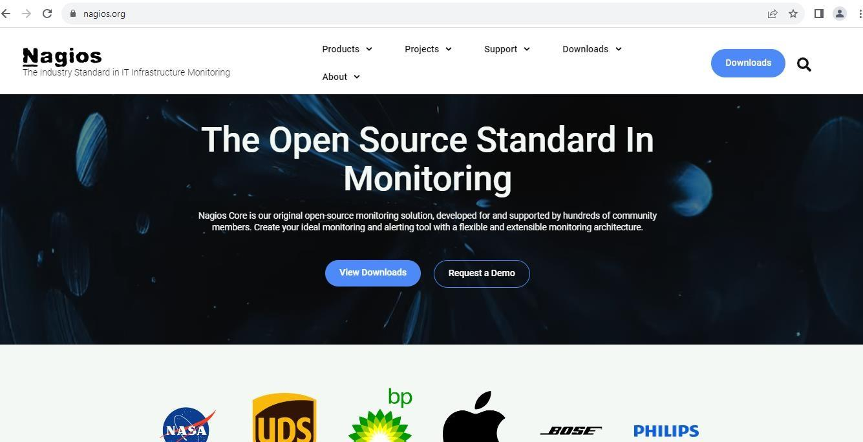

Step 2 : Download Nagios XI.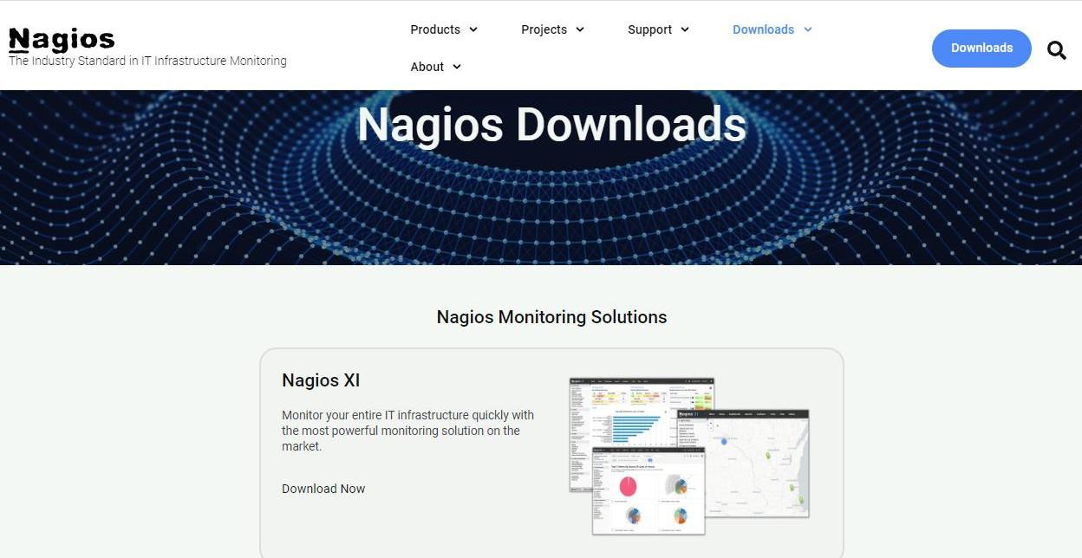

Step 3 : Click on Download for VMWare.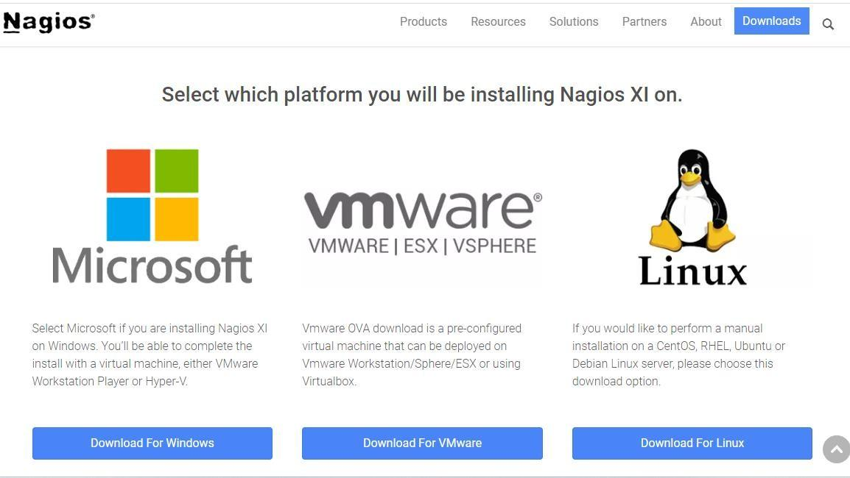

Step 4 : Now, click on Workstation Pro/Player.

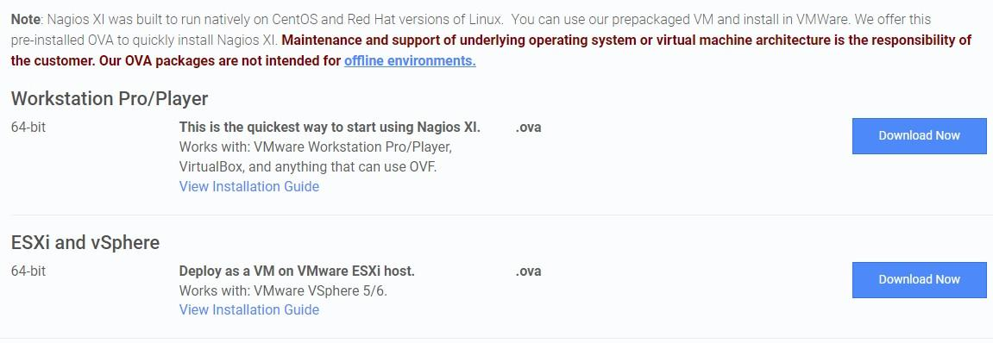

Step 5 : Fill in the details.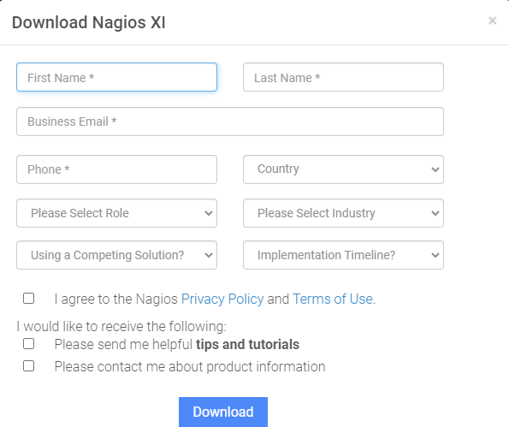

Step 6 : Go to downloads folder and open the downloaded file.

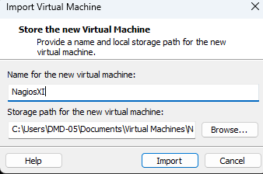

Step 7 : Now, the virtual machine has started to import Nagios XI.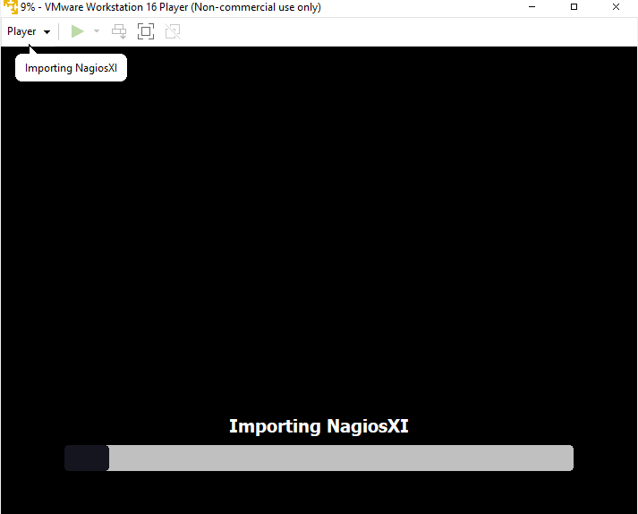

Step 8 : Nagios XI has started successfully in Virtual Machine.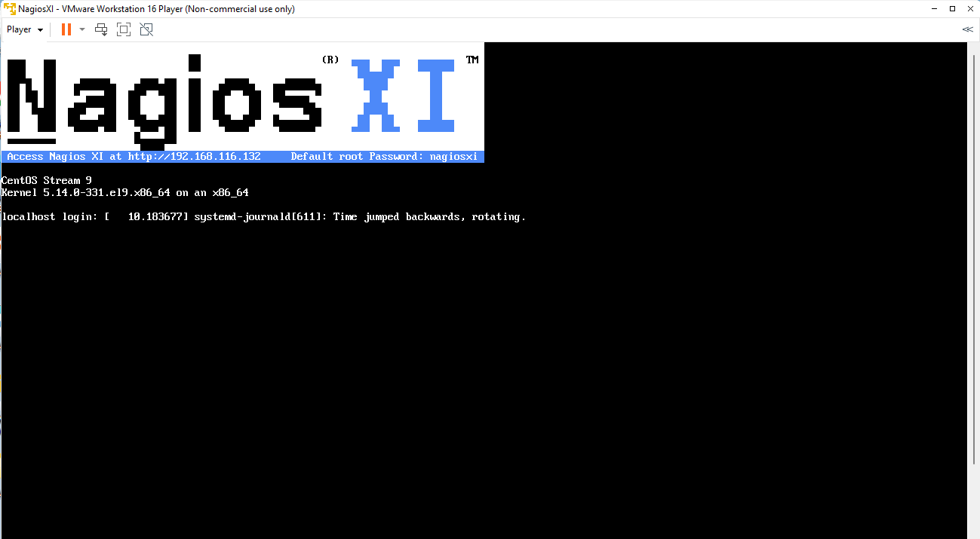

Step 9 : Now, start the IP Address generated after installation by Nagios XI and click on Access Nagios XI to setup it.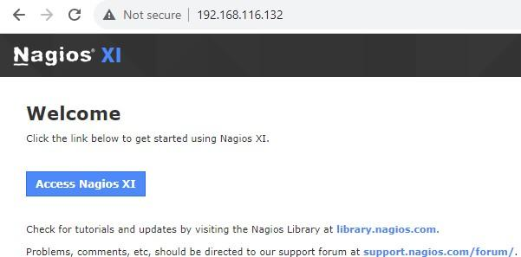

Step 10 : Now set the general system settings for Nagios XI installation and click Next.

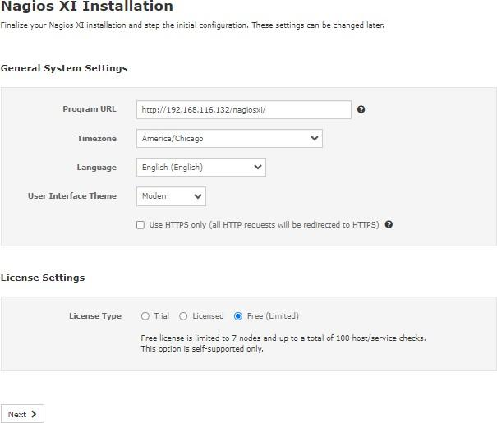

Step 11 : Now, set the admin system settings for Nagios XI installation.

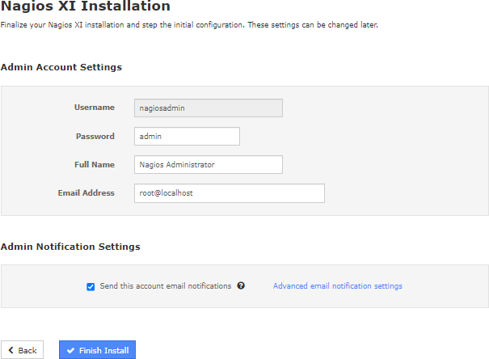

Step 12 : Installation Successful and click on Login to Nagios XI.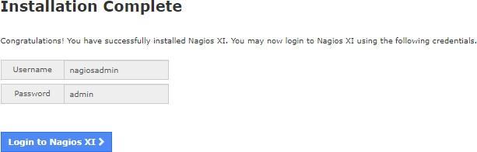

Step 13 : Now Login to Nagios XI.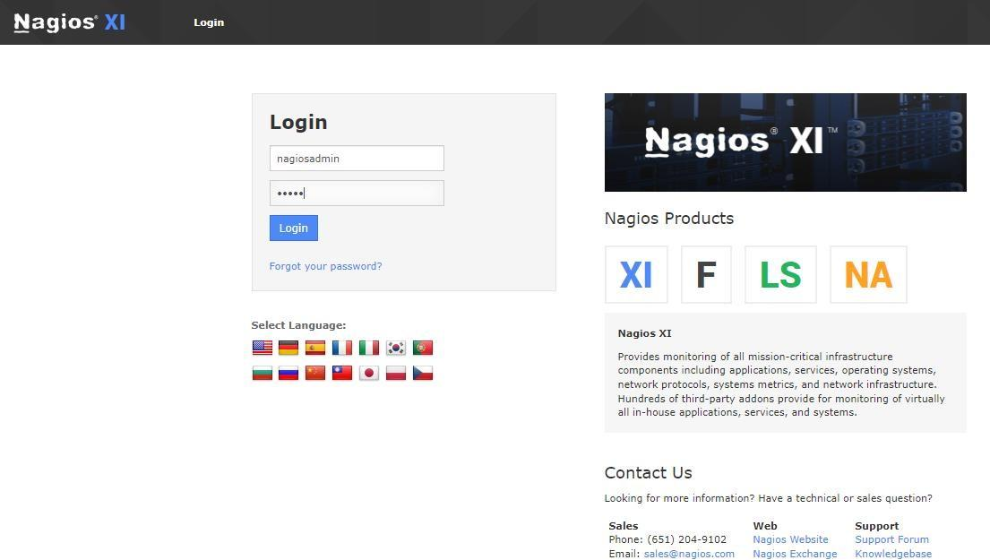

Step 14 : Now, click on Submit.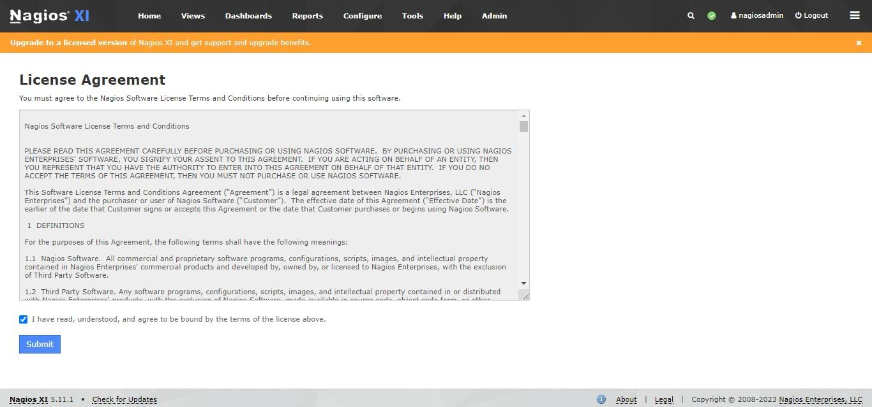

Step 15 : Now, Nagios XI Home Dashboard gets displayed & thus, we have logged in successfully.

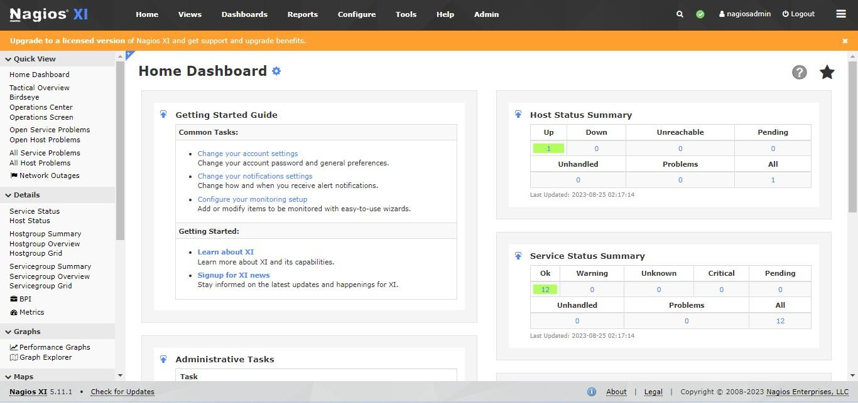

**CONCLUSION :-**